SENTIMENT ANALYSIS

Navigating the Landscape of Emotion in Textual Data

A Project Report Submitted to
Jawaharlal Nehru Technological University Kakinada, Kakinada in partial fulfillment for the award of the degree of

BACHELOR OF TECHNOLOGY
IN
COMPUTER SCIENCE AND ENGINEERING(DS)

Submitted by
A. SNEHIKA (20KN1A4402)



DEPARTMENT OF COMPUTER SCIENCE AND ENGINEERING

NRI INSTITUTE OF TECHNOLOGY
Autonomous

(Approved by AICTE, Permanently Affiliated to JNTUK, Kakinada) Accredited by NBA (CSE, ECE & EEE), Accredited by NAAC with ‘A’ Grade ISO 9001: 2015 Certified Institution
Pothavarappadu (V), (Via) Nunna, Agiripalli (M), Eluru Dist., PIN: 521212, A.P, India.

2023-2024

 | NRI INSTITUTE OF TECHNOLOGY  (An Autonomous Institution, Approved by AICTE, Permanently Affiliated to JNTUK, Kakinada)  Accredited by NBA (CSE, ECE & EEE), Accredited by NAAC with ‘A’ Grade ISO 9001: 2015 Certified Institution  Pothavarappadu (V), (Via) Nunna, Agiripalli (M), Eluru Dist., PIN: 521212, A.P, India.

CERTIFICATE

This is to certify that the Project entitled “SENTIMENT ANALYSIS” submitted by A. Snehika(20KN1A4402), is the work done by me and submitted during 2023-2024 academic year, in partial fulfillment of the requirements for the award of the degree of BACHELOR OF TECHNOLOGY in COMPUTER SCIENCE AND ENGINEERING - DATA SCIENCE to Jawaharlal Nehru Technological University Kakinada, and it has been found worthy of acceptance according to the requirements of the university.

Project Guide Head of the Department

(CH. V Murali Krishna) (CH. V Murali Krishna)

INTERNAL EXAMINER EXTERNAL EXAMINER

ACKNOWLEDGEMENT

I take this opportunity to thank all who have rendered their full support to my work. The pleasure, the achievement, the glory, the satisfaction, the reward, the appreciation and the construction of my project cannot be expressed with a few words for their valuable suggestions.

I am expressing my heartfelt thanks to Head of the Department, Mr. CH. V. MURALI KRISHNA garu for his continuous guidance for completion of my Project work.

I am extending my sincere thanks to Dean of the Department, Dr. K. V. SAMBASIVARAO for his continuous guidance and support to complete my project successfully. I am thankful to the Principal, Dr. C. NAGA BHASKAR garu for his encouragement to complete the Project work.

I am extending sincere and honest thanks to the Chairman, Dr. R. VENKATA RAO garu for their continuous support in completing the Project work.

Finally, I thank the Administrative Officer, Staff Members, Faculty of Department of CSE, NRI Institute of Technology and my friends, directly or indirectly helped me in the completion of this project.

Project Associates

A. Snehika(20KN1A4402)

DECLARATION

I, Ms. A. Snehika hereby declare that the project report entitled “SENTIMENT ANALYSIS” is an original work done in the Department of Computer Science & Engineering (Data Science), NRI Institute of Technology, Pothavarappadu(V), Agiripalli (M), Eluru District during the academic year 2023-2024, in partial fulfillment for the award of the Degree of Bachelor of Technology in Computer Science & Engineering (Data Science). We assure you that this project is not submitted to any other College or University.

Project Associates Signature
A. Snehika (20KN1A4402)

TABLE OF CONTENT
CHAPTER NO. TITLE PAGE NO.

ABSTRACT ix
CHAPTER 1 INTRODUCTION
1.1 INTRODUCTION 2
1.2 PROBLEM DEFINITION 2
1.3 SOLUTION FOR PROBLEM DEFINITION 3
1.4 PROCESS DIAGRAM 4
CHAPTER 2 LITERATURE REVIEW 5
CHAPTER 3 SYSTEM ANALYSIS
3.1 OBJECTIVE 7
3.2 EXISTING SYSTEM 7
3.3 PROPOSED SYSTEM 7
3.4 ANALYSIS MODEL 7
3.5 MODULES 8
CHAPTER 4 FEASIBILITY STUDY
4.1 TECHNICAL 10
4.2 ECONOMICAL 11
4.3 OPERATIONAL 12
CHAPTER 5 SOFTWARE REQUIREMENTS SPECIFICATION
5.1 INTRODUCTION 14
5.2 FUNCTIONAL REQUIREMENTS 16
5.3 NON-FUNCTIONAL REQUIREMENTS 17
5.4 SYSTEM REQUIREMENTS 18
5.4.1 SOFTWARE REQUIREMENTS 18
5.4.2 HARDWARE REQUIREMENTS 18

CHAPTER 6 SYSTEM DESIGN
6.1 UML MODELING 21
6.1.1 IMPORTANCE OF UML IN MODELING 21
6.2 CLASS DIAGRAM 22
6.3 USE-CASE DIAGRAM 22
6.4 SEQUENCE DIAGRAM 23

CHAPTER 7 CODING
7.1 SOFTWARE DESCRIPTION 25
7.2 CODE 27
CHAPTER 8 RESULTS 33
CHAPTER 9 ADVANTAGES AND APPLICATIONS
9.1 APPLICATIONS 37
9.2 USE CASES 37
CHAPTER 10 CONCLUSION 39
CHAPTER 11 FUTURE ENHANCEMENT 41
CHAPTER 12 REFERENCES 43
CHAPTER 13 CERTIFICATES 45
CHAPTER 14 PUBLICATION 48

ABSTRACT

The objective of the natural language processing (NLP) aspect of sentiment analysis is to automatically distil and aggregate sentiments from textual sources, such as online reviews and consumer feedback. This research proposes a methodology for categorizing Amazon food reviews on a scale of 1 to 5 based on expressed sentiments within the text, utilizing sentiment analysis techniques. Employing machine learning algorithms, the system discerns the overall sentiment conveyed in reviews by analyzing linguistic patterns within them. Data preprocessing techniques, including text cleansing, tokenization, and noise reduction, are applied to prepare the data for analysis. The textual data is then transformed into numerical representations using feature extraction methods such as bag-of-words and TF-IDF. Supervised learning algorithms, including logistic regression, support vector machines (SVM), and random forests, are trained on the pre-processed data to develop sentiment categorization models. The efficacy of these models is evaluated through pertinent metrics to determine the optimal approach. A pivotal aspect of this proposed methodology involves the presentation of sentiment analysis outcomes through word clouds, visually highlighting key terms and expressions influencing both positive and negative sentiment ratings. These visualizations offer businesses valuable insights into factors shaping consumer perceptions and preferences. Overall, this research equips businesses with a valuable tool to monitor and comprehend public sentiment regarding their food products, facilitating data-informed decision-making to enhance customer satisfaction and competitive positioning in the marketplace. The integration of NLP, machine learning, and visualization techniques demonstrates the system's capacity to extract actionable insights from extensive volumes of user-generated content.
Keywords: Sentiment Analysis, Natural Language Processing (NLP), Amazon Food Reviews, Machine Learning, Text Preprocessing, Feature Extraction, Supervised Learning, Logistic Regression, Support Vector Machines (SVM), Customer Satisfaction.

CHAPTER-1
INTRODUCTION

1. INTRODUCTION

1.1 INTRODUCTION

The rapid expansion of the web has led to an unprecedented abundance of user-generated content, including customer feedback, opinions, and reviews. This influx of data presents both opportunities and challenges for businesses seeking to understand public sentiment towards their products and services. Sentiment analysis, a subfield of natural language processing (NLP), addresses this challenge by automating the extraction and aggregation of opinions from textual data on the web.

In this project, we propose a system for sentiment analysis that aims to classify user reviews on a scale of 1 to 5 based on the sentiments expressed within the text. Our approach leverages machine learning techniques to analyze the language used in reviews and determine the overall sentiment conveyed. By assigning numerical ratings to reviews, we provide businesses with a quantitative measure of customer satisfaction and perception.

A key feature of our system is the visualization of sentiment analysis results through word clouds. These word clouds highlight the groups of words that contribute most significantly to the overall sentiment rating of a review. By visualizing the prominent words and phrases, businesses can gain deeper insights into the factors driving customer opinions and preferences.

The proposed system offers a valuable tool for businesses to monitor and understand public sentiment towards their products and services in real-time. By effectively harnessing the vast amount of user-generated content on the web, businesses can make data-driven decisions to enhance customer satisfaction and improve market competitiveness.

1.2 PROBLEM DEFINITION

The core challenge addressed by this research project is the need to accurately classify Amazon food reviews as positive or negative sentiments. Given the sheer volume of textual data and the inherent complexities of natural language, determining the sentiment polarity of reviews manually is a daunting task. Therefore, the project seeks to develop an automated method to analyze reviews and assign a sentiment label (positive or negative) to each review based on the sentiments expressed within the text.

1.3 SOLUTION FOR PROBLEM DEFINITION

To address the identified problem, the research proposes the utilization of machine learning techniques to train models capable of classifying Amazon food reviews as either positive or negative sentiments. The solution involves preprocessing the textual data to enhance its quality and relevance, followed by the development and training of sentiment classification models. These models will learn to identify patterns and linguistic cues indicative of positive or negative sentiments, thereby enabling automated sentiment analysis of Amazon food reviews.

1.4 PROCESS DIAGRAM

The process diagram illustrates the sequential stages involved in sentiment analysis of Amazon food reviews, including data preprocessing, model training, and sentiment classification. This visual depiction offers a comprehensive overview of the systematic approach adopted in the research project, providing stakeholders with a clear understanding of the methodology employed.
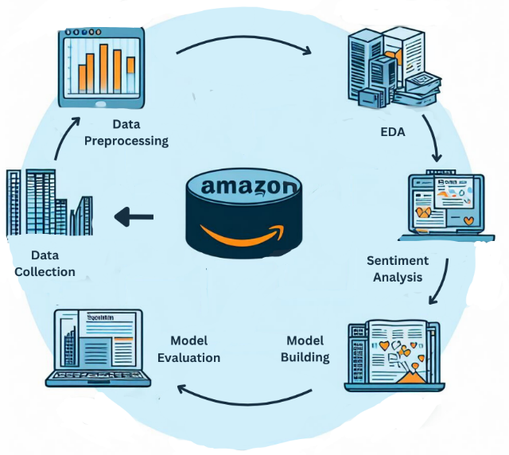
FIG1: PROCESS DIAGRAM

CHAPTER-2
LITERATURE REVIEW
Title | Journal | Published Year | Advantages | Limitations  2. LITERATURE REVIEW
Sentiment Analysis of Large-Scale Amazon Product Reviews | IEEE International Conference on Innovative Research and Development (ICIRD) | 2018 | Provided insights into sentiment analysis of large-scale Amazon product reviews. Leverages sentiment analysis techniques on vast datasets. | Challenges in extracting meaningful sentiments from vast amounts of user-generated content.
Sentiment Analysis and Visualization of Amazon Books' Reviews | 2nd International Conference on Computer Applications & Information Security (ICCAIS) | 2019 | Explored sentiment analysis and visualization of Amazon books' reviews. Emphasized importance of visualizing sentiment trends for data interpretation. | Computational complexity may increase with extensive data visualization.
Twitter Sentiment Analysis with Different Feature Extractors | IEEE Annual India Conference (INDICON) | 2016 | Investigated Twitter sentiment analysis using various feature extractors and techniques. Provided insights into feature extraction impact on accuracy. | Overfitting risks with certain feature extraction methods.
Sentiment Analysis for Code-Mixed Indian Social Media Text | International Conference on Advances in Computing, Communications and Informatics (ICACCI) | 2018 | Explored sentiment analysis for code-mixed Indian social media text. Offered novel approaches for sentiment analysis in diverse linguistic contexts. | Limited to specific language contexts, may not generalize well to other languages.
Advanced Twitter Sentiment Analysis Using Supervised Techniques | (Publication Year Not Provided) | 2020 | Conducted advanced Twitter sentiment analysis using supervised techniques and features. Demonstrated effectiveness in capturing nuanced sentiments. | Effectiveness may vary depending on data quality and diversity.

CHAPTER-3
SYSTEM ANALYSIS

3. SYSTEM ANALYSIS

3.1 OBJECTIVE

The overarching objective of this project is to engineer a sophisticated sentiment analysis system tailored specifically for the Amazon food reviews domain. The system aims to revolutionize the way businesses interpret customer feedback by automating the process of sentiment extraction and classification. By analyzing textual data from Amazon food reviews, the system seeks to provide actionable insights that can inform decision-making processes, enhance customer satisfaction, and drive business growth.

3.2 EXISTING SYSTEM

A comprehensive analysis of existing sentiment analysis systems and tools was undertaken to discern their strengths, weaknesses, and applicability to the Amazon food reviews domain. Numerous commercial and open-source solutions were evaluated, each offering varying degrees of accuracy, scalability, and feature richness. However, it was observed that none of the existing systems adequately addressed the unique challenges posed by analyzing sentiment in Amazon food reviews at scale.

3.3 PROPOSED SYSTEM

The proposed sentiment analysis system represents a novel approach to analyzing Amazon food reviews, leveraging cutting-edge machine learning algorithms and natural language processing techniques. By integrating advanced sentiment classification models with sophisticated data preprocessing pipelines, the system aims to extract nuanced sentiments from textual data with unparalleled accuracy and efficiency. Furthermore, the system will incorporate innovative visualization techniques to present sentiment analysis results in a visually appealing and interpretable manner.

3.4 ANALYSIS MODEL

The analysis model for the sentiment analysis system encompasses a multifaceted approach that encompasses several interconnected components. The data preprocessing component encompasses a range of techniques including text cleaning, tokenization, and noise removal to ensure the integrity and quality of the textual data. Feature extraction techniques such as bag-of-words, word embeddings, and TF-IDF will be employed to transform the textual data into numerical representations suitable for machine learning models. The sentiment classification component will encompass the training and deployment of state-of-the-art supervised learning models, including logistic regression, support vector machines (SVM), and deep neural networks, to accurately classify reviews into positive, negative, or neutral sentiments. Finally, the visualization component will utilize advanced visualization techniques such as word clouds, sentiment heatmaps, and sentiment trend analysis graphs to provide intuitive and insightful visualizations of sentiment analysis results.

3.5 MODULES

The sentiment analysis system will be modularized into several distinct modules to facilitate the development, testing, and maintenance processes. These modules include:

1. Data Loading and Exploration:
To load Amazon Fine Food reviews into your programming environment, use libraries like Pandas in Python for structured formats like CSV or Excel. If the dataset is in a different format, use other methods. Examine the dataset's structure to understand its format, size, attributes, and column names to ensure they match your expectations.

2. Data Preprocessing Module:
Responsible for cleaning, tokenizing, and preprocessing textual data.

3. Feature Engineering:
Extracts relevant features from preprocessed text using various techniques.

4. Model Selection and Training:
For model selection and training in a sentiment analysis project on Amazon Fine Food reviews, where logistic regression, SVM (Support Vector Machines), and random forest are considered.
- Logistic Regression is a simple and interpretable model suitable for binary classification tasks like sentiment analysis. It learns the relationship between input features and binary sentiment labels.
- Support Vector Machines (SVM) are effective for high-dimensional feature spaces and aim to find the hyperplane that best separates data points of different classes.
- Random Forest is an ensemble learning method that builds multiple decision trees during training and combines their predictions through voting or averaging. It is robust to overfitting and can handle noisy data.

5. Model Evaluation:
The study evaluated sentiment analysis models on Amazon Fine Food reviews using logistic regression, SVM, and random forest classifiers. Performance metrics included accuracy, precision, recall, and F1 score. Cross-validation techniques like k-fold cross-validation were used to ensure generalizability. Hyperparameter tuning was performed to optimize parameters, and feature importance was investigated for random forest. The goal was to select the most effective approach for sentiment analysis.

6. Fine Tuning and Optimization:
The study focused on optimizing sentiment analysis models for Amazon Fine Food reviews, enhancing predictive performance and generalization capabilities. Hyperparameter tuning was performed on logistic regression, SVM, and random forest classifiers, adjusting parameters like regularization strength, kernel type, and depth. Features selection and engineering were also explored to improve interpretability and efficiency.

7. Deployment and Integration:
The sentiment analysis project on Amazon Fine Food reviews uses logistic regression models. The model is trained on a labelled review dataset, tested for accuracy and performance metrics, and integrated into a web application or API. This requires setting up a server infrastructure, implementing model inference endpoints, and ensuring scalability and reliability. Continuous monitoring and updating of the model may be necessary to maintain accuracy. Thorough documentation and user-friendly interfaces are also necessary for ease of use.

Each module will be meticulously designed and implemented to ensure modularity, scalability, and maintainability of the sentiment analysis system. This detailed analysis of the sentiment analysis system outlines its objectives, components, and modular architecture, laying the foundation for the subsequent chapters focused on implementation and evaluation.
CHAPTER-4
FEASIBILITY STUDY

4. FEASIBILITY STUDY

4.1 TECHNICAL
Data Collection and Preprocessing:
- Obtain a large dataset of Amazon Fine Food reviews.
- Preprocess the data by removing noise, tokenization, stemming, and stop words.
- Split the data into training, validation, and test sets.
Feature Engineering:
- Extract relevant features from the text data.
- Explore additional features like review length, sentiment lexicons, or metadata.
Model Selection and Training:
- Implement logistic regression, SVM, and random forest classifiers.
- Train each model on the training set and tune hyperparameters using cross-validation.
- Evaluate models using the validation set and select the best-performing model.
Model Evaluation:
- Assess the performance of each model on the test set.
- Conduct error analysis to understand common misclassifications and areas for improvement.
- Compare the performance of different models and identify trade-offs.
Scalability and Efficiency:
- Consider the scalability of the chosen models to handle large volumes of reviews efficiently.
- Evaluate computational resources required for training and inference.
Deployment and Integration:
- Develop a pipeline for deploying the chosen model(s).
- Integrate the sentiment analysis functionality into the target application or platform.
Monitoring and Maintenance:
- Implement monitoring mechanisms to track model performance.
- Establish a maintenance plan for updating the model periodically.

4.2 ECONOMICAL

Cost of Data Acquisition and Storage:
- The project requires a large dataset of Amazon Fine Food reviews, which may involve costs related to acquiring the data from relevant sources or purchasing it from data providers.
- Additionally, the storage and management of such a large dataset can incur costs related to cloud storage or on-premises infrastructure.

Computational Resources:
- Training and deploying machine learning models like logistic regression, SVM, and random forest can be computationally intensive, especially when dealing with large datasets.
- This may require investing in powerful hardware resources, such as high-performance computing systems, or utilizing cloud-based computing services, which can incur additional costs.

Software and Tool Costs:
- The project may require the use of specific software tools or libraries for data preprocessing, feature engineering, model training, and deployment.
- Some of these tools may have associated licensing costs or subscription fees, which should be accounted for in the economic feasibility study.

Human Resources:
- The project may require skilled professionals, such as data scientists, machine learning engineers, and software developers, to develop and maintain the sentiment analysis system.
- The costs associated with hiring, training, and retaining such personnel should be considered.

Deployment and Maintenance:
- Once the sentiment analysis system is developed, it needs to be deployed and integrated into existing business processes or applications.
- This may involve costs related to infrastructure setup, integration efforts, and ongoing maintenance and support.

Potential Benefits and Cost Savings:
- On the other hand, the successful implementation of the sentiment analysis system can provide significant benefits and cost savings to the business.
- By accurately analyzing customer sentiments, businesses can make informed decisions about product improvements, marketing strategies, and customer service initiatives, potentially leading to increased customer satisfaction, loyalty, and revenue.
- Additionally, the system can help streamline and automate the process of analyzing large volumes of customer feedback, reducing manual effort and associated costs.

4.3 OPERATIONAL

Data Availability and Quality:
- Project accesses a large dataset of 500,000 Amazon Fine Food reviews.
- Data preprocessing steps like handling null values, duplicate removal, and text cleaning identified as potential issues.
Technical Expertise and Resources:
- Requires expertise in natural language processing, machine learning algorithms, and data preprocessing techniques.
- Document shows good understanding and implementation of these techniques.
- Computational resources required for training and deploying models not specified.
User Acceptance and Training:
- No mention of end-users or stakeholders or required user training.
- User acceptance depends on factors like user-friendliness, interpretability of results, and integration with existing workflows.
Maintenance and Support:
- Lack of information about maintenance and support plans for the sentiment analysis system.

Data Management and Storage:
- The document does not provide details on how the large dataset of Amazon Fine Food reviews will be managed and stored.
- Operational considerations include setting up a robust data storage and management system, data backup and recovery strategies, and ensuring data security and privacy compliance.

Model Versioning and Monitoring:
- As the project involves training and deploying machine learning models, it is essential to have a versioning system in place to track model updates and changes.
- Monitoring the performance of the deployed models over time and identifying potential drift or degradation in performance is crucial for maintaining the accuracy and reliability of the sentiment analysis system.

Automated Testing and Continuous Integration/Deployment:
- To ensure the smooth and efficient deployment of updates and changes to the sentiment analysis system, an automated testing and continuous integration/deployment pipeline should be established.
- This includes setting up automated tests for the data preprocessing, feature engineering, and model training components, as well as automating the deployment process to different environments (e.g., development, staging, production).

Scalability and Load Balancing:
- The document does not address the potential scalability requirements of the sentiment analysis system, especially if it needs to handle a growing volume of reviews or support multiple concurrent users or requests.
- Operational considerations include implementing load balancing strategies, horizontal scaling (adding more computational resources), and optimizing resource utilization.

Error Handling and Logging:
- Proper error handling and logging mechanisms should be implemented to ensure the system's stability and facilitate debugging and troubleshooting.
- This includes logging errors and exceptions at different stages of the sentiment analysis pipeline (data preprocessing, feature engineering, model inference), as well as providing clear error messages and notifications to end-users.

Documentation and Knowledge Transfer:
- Comprehensive documentation of the sentiment analysis system, including data sources, preprocessing steps, feature engineering techniques, model training and evaluation processes, and deployment procedures, is crucial for effective knowledge transfer and system maintenance.
- Operational considerations include establishing documentation standards, version control, and providing training or knowledge-sharing sessions for the team responsible for maintaining and supporting the system.

Security and Access Control:
- Depending on the sensitivity of the data and the deployment environment, security measures and access control mechanisms may need to be implemented to protect the sentiment analysis system and the underlying data.
- This could include measures such as data encryption, role-based access control, and secure communication protocols.

CHAPTER-5
SOFTWARE
REQUIREMENTS
SPECIFICATIONS

5. SOFTWARE REQUIREMENTS SPECIFICATIONS

5.1 INTRODUCTION
The software requirement specification can produce at the culmination of the analysis task. The function and performance allocated to software as part of system engineering are refined by established a complete information description, a detailed functional description, a representation of system behavior, and indication of performance and design constrain, appropriate validate criteria, and other information pertinent to requirements.
System Requirements Specification:

The System Requirements Specification represents a compilation of information encapsulating the essential requirements of a system. Business analysts, often referred to as system analysts, play a pivotal role in analyzing the business needs of clients and stakeholders to identify business problems and propose viable solutions. Projects typically encompass three main types of requirements:

- Business Requirements: These articulate what needs to be delivered or achieved in business terms to provide value.
- Product Requirements: These delineate the properties of the system or product, offering various solutions to fulfill a set of business requirements.
- Process Requirements: These specify the activities undertaken by the development organization, often delineating methodologies to be followed and constraints to be adhered to.

Product and process requirements are intricately linked, with process requirements often dictating the activities necessary to satisfy product requirements. For instance, a maximum development cost requirement may be imposed to achieve a maximum sales price requirement, while requirements for maintainability are addressed through specified development styles.

In system engineering, requirements can be categorized into Functional Requirements, which describe what the system must do, and Non-functional Requirements, which define aspects of the system's performance or quality of service. Non-functional requirements, also known as Performance requirements, encompass characteristics such as usability, availability, reliability, supportability, testability, and maintainability.

An effective collection of requirements outlines the characteristics or features desired in the system. It is crucial for requirements to refrain from dictating how the system should be implemented, leaving such decisions to the system designer. Expressing implementation constraints is permissible, such as required interfaces to external systems, interoperability with other systems, and alignment with other owned products.

5.1.1 OVERVIEW OF PYTHON

Python Libraries: The document extensively utilizes various Python libraries such as nltk, numpy, pandas, matplotlib, seaborn, collections, wordcloud, and sklearn for tasks like natural language processing, data manipulation, visualization, and machine learning model development.

Data Processing and Analysis: The document outlines several data processing steps, including handling null values, removing unwanted features, combining and cleaning text data, preprocessing the time column, handling duplicate data, and cleaning text for sentiment analysis. Techniques such as TF-IDF vectorization and frequency distribution analysis are also employed for data analysis.

Model Development and Evaluation: Machine learning models, including logistic regression, support vector machines (SVM), and random forest classifiers, are developed and evaluated for sentiment analysis. The accuracy of the sentiment analysis model is calculated using the accuracy_score metric.

Integration with Existing Systems: Although the document does not explicitly mention integration with existing systems, the sentiment analysis models and data processing techniques described can potentially be integrated into existing systems for analyzing customer reviews and feedback.

Community Support and Resources: References to external resources and tutorials are provided in the document, indicating reliance on community support for learning and implementing various techniques and algorithms related to sentiment analysis, natural language processing, and machine learning.

Cross-Platform Compatibility: Python is inherently cross-platform compatible, and the libraries and techniques mentioned in the document can be used on different operating systems such as Windows, macOS, and Linux without significant modifications.

Scalability and Performance: Python and its associated libraries are known for their scalability and performance capabilities, especially when utilizing optimized data processing and machine learning algorithms for large datasets.

5.1.2 GOOGLE COLAB OVERVIEW

Purpose and Context: Google Colab serves as a cloud-based Python environment that allows users to execute code collaboratively in real-time. It is particularly useful for projects involving data science, machine learning, and natural language processing due to its integration with Jupyter notebooks and access to powerful computing resources.

Data Processing and Analysis: In the document, Google Colab could be utilized for data preprocessing tasks such as loading the dataset (`food_reviews_csv_excel.csv`), cleaning the data, handling missing values, and performing exploratory data analysis. With Google Colab's ability to access files directly from Google Drive, users can easily import datasets and manipulate them using pandas and numpy libraries within a Jupyter notebook environment.

Model Development and Evaluation: For model development, Google Colab provides access to GPU and TPU resources, which can significantly accelerate training times for machine learning models. Users can leverage libraries such as scikit-learn (`LogisticRegression`, `TfidfVectorizer`) and TensorFlow/Keras for building and evaluating sentiment analysis models. The collaborative nature of Google Colab allows team members to work together on model development, share code snippets, and iterate on model architectures.

Integration with Existing Systems: While the document does not explicitly mention integration with existing systems, Google Colab offers seamless integration with Google Drive, allowing users to save and access notebooks, datasets, and trained models directly from their Google Drive account. This integration facilitates collaboration and sharing among team members and ensures that project artifacts are securely stored in the cloud.

Community Support and Resources: Google Colab benefits from a large and active community of data scientists, researchers, and educators. Users can leverage community-contributed notebooks, tutorials, and code snippets to accelerate their projects. Additionally, Google provides extensive documentation and resources for getting started with Google Colab, including sample notebooks, video tutorials, and user forums.

Cross-Platform Compatibility: Google Colab is accessible via web browsers and does not require any installation or setup, making it compatible with various operating systems, including Windows, macOS, and Linux. Users can seamlessly switch between different devices and platforms while working on their projects, providing flexibility and convenience.

Scalability and Performance: One of the key advantages of Google Colab is its scalability and performance. By leveraging Google's infrastructure, users can harness the computing power of GPUs and TPUs to train large-scale machine learning models efficiently. This scalability ensures that users can tackle complex projects and handle large datasets without being limited by hardware constraints.
5.2 FUNCTIONAL REQUIREMENT
1.Data Preprocessing: Prepare the dataset for analysis by cleaning, transforming, and structuring the data. Remove rows with null values to ensure data quality. Convert Unix time format to datetime format for easier interpretation. Handle duplicate records to prevent skewing of analysis results. Clean text data by removing punctuation, special characters, and stop-words.
2. Exploratory Data Analysis (EDA): Gain insights and understanding of the dataset before model development. Perform statistical analysis to summarize dataset characteristics. Visualize data distributions and relationships between features. Explore correlations and patterns in the data to inform model selection and feature engineering.
3. Feature Engineering: Create new features or transform existing ones to improve model performance. Combine summary and text columns into a single feature for comprehensive analysis. Calculate helpfulness score based on user feedback. Extract relevant information from text data, such as sentiment indicators and key phrases.
4. Model Development: Build machine learning models to classify sentiment based on review data. Implement various classification algorithms such as logistic regression, support vector machines (SVM), and random forest. Train models on labeled data to learn patterns and relationships between features and sentiment labels. Evaluate model performance using metrics like accuracy, precision, recall, and F1-score.
5. Model Evaluation: Assess the effectiveness and accuracy of the sentiment analysis models. Split the dataset into training and testing sets to evaluate model generalization. Use cross-validation techniques to validate model performance and avoid overfitting. Compare different models and select the one with the best performance for deployment.
6. Integration with Existing Systems: Integrate sentiment analysis functionality into existing applications or workflows. Provide APIs or interfaces for seamless integration with other systems. Ensure compatibility with existing data pipelines and processing workflows. Support real-time analysis and batch processing of review data as needed.
7. Deployment and Monitoring: Deploy sentiment analysis models into production environments and monitor performance. Deploy models to cloud-based platforms or on-premises servers for scalability and accessibility. Implement logging and monitoring mechanisms to track model predictions and performance metrics. Continuously update and retrain models to adapt to changing data and user feedback.
8. Documentation and Support: Ensure that users have access to comprehensive documentation and support resources. Provide detailed documentation on system architecture, functionality, and usage. Offer user guides, tutorials, and troubleshooting tips for developers and end-users. Establish channels for community support, including forums, chat rooms, and email support.
9. Security and Privacy: Protect sensitive data and ensure compliance with privacy regulations. Implement data encryption and access controls to safeguard user information. Adhere to industry standards and best practices for data handling and storage. Conduct regular security audits and vulnerability assessments to identify and mitigate potential risks.
5.3 NON-FUNCTIONAL REQUIREMENT
1. Performance: Ensure the system can handle large volumes of data and provide timely responses. The system should be able to process and analyze reviews efficiently, even with millions of records. Response times for sentiment analysis should be fast, allowing users to obtain results in seconds or less. The system should scale horizontally to accommodate increasing workloads and user demands.
2. Scalability: Enable the system to grow and adapt to changing requirements and usage patterns. The architecture should be designed for horizontal scalability, allowing new resources to be added easily. Components of the system should be decoupled to facilitate independent scaling of different modules. Scalability testing should be conducted to identify bottlenecks and optimize resource allocation.
3. Reliability: Ensure the system operates consistently and reliably under normal and peak loads. The system should have high availability, with minimal downtime for maintenance or upgrades. Fault tolerance mechanisms should be in place to handle errors and failures gracefully. Data integrity and consistency should be maintained, even in the event of system failures or crashes.
4. Security: Protect sensitive data and ensure compliance with privacy regulations. Access controls should be enforced to restrict unauthorized access to data and system resources. Data encryption should be used to secure data transmission and storage. User authentication and authorization mechanisms should be implemented to verify user identities and permissions.
5. Usability: Ensure the system is easy to use and understand for both technical and non-technical users. The user interface should be intuitive and user-friendly, with clear navigation and instructions. Documentation and help resources should be comprehensive and readily accessible. The system should support multiple languages and provide localization options for global users.
6. Maintainability: Facilitate system maintenance, updates, and enhancements over time. The system should be well-documented, with clear guidelines for configuration and customization. Code should be modular and well-organized, with comments and annotations for easier understanding. Automated testing and continuous integration practices should be implemented to detect and prevent regressions.
7. Interoperability: Ensure the system can seamlessly integrate with other systems and technologies. The system should support standard data formats and protocols for interoperability. APIs and web services should be provided for integration with third-party applications and platforms. Compatibility with common programming languages, frameworks, and databases should be ensured.
8. Compliance: Ensure the system complies with relevant laws, regulations, and industry standards. The system should adhere to data protection regulations such as GDPR and HIPAA. Compliance certifications and audits should be conducted regularly to verify adherence to standards. Legal and ethical considerations should be addressed, particularly regarding the use of personal data and user privacy
9. Performance Monitoring and Logging: Enable real-time monitoring and tracking of system performance and usage. Logging mechanisms should capture relevant metrics, errors, and events for analysis and troubleshooting. Performance monitoring tools should be used to detect anomalies and optimize system performance. Alerts and notifications should be configured to alert administrators of critical issues or performance degradation
10. Training and Support: Ensure users have the knowledge and resources to effectively use and maintain the system. Training materials and resources should be provided to educate users on system functionality and best practices. Technical support channels should be available to assist users with troubleshooting and problem resolution. Regular updates and communications should be provided to inform users of system changes, updates, and enhancements
5.4 SYSTEM REQUIREMENTS
5.4.1 SOFTWARE REQUIREMENTS
      - Python 3.11.3: Programming language for developing and executing the code.
      - Google Colab: Platform for running code seamlessly without requiring local dataset storage.
      - VSCode: Integrated development environment for code editing and management.
      - Jupyter Notebook: Interactive environment for code experimentation and documentation.
      - Compatibility with the latest versions of each software component.
5.4.2 HARDWARE REQUIREMENTS
        - Hardware Requirement
        - Processor: Intel Core i5 12th Gen 12500H for efficient computation.
        - RAM: Integrated 16 GB for handling large datasets and model training.
        - Storage: 512GB storage capacity for storing codebase and datasets.
        - GPU: Integrated 8GB Iris Xe GPU for accelerated deep learning tasks.
        - Adequate cooling system to maintain optimal performance during intensive computations.

CHAPTER-6
SYSTEM DESIGN

6. SYSTEM DESIGN

6.1 Introduction:
Systems design encompasses the meticulous process of delineating the architecture, modules, interfaces, and data of a system to fulfill predetermined requirements. It could be perceived as the application of systems theory to the development of products, overlapping with disciplines such as systems analysis, systems architecture, and systems engineering. Key aspects of system design include:
- Creativity: It involves a creative process rather than relying on predetermined solutions.
- Goal orientation: It is driven by specific objectives.
- Problem-solving: The design aims to address particular problems.
- Constraints: Designs are influenced by various constraints including functional requirements and available resources.
- Recognizable quality: Well-designed systems are characterized by simplicity, coherence, meeting requirements adequately, and adaptability.

System design transitions from the analysis model by:
- Establishing project design goals.
- Breaking down the system into smaller subsystems.
- Choosing off-the-shelf and legacy components.
- Aligning subsystems with hardware.
- Selecting appropriate persistent data management infrastructure.
- Determining access control policies.
- Determining global control flow mechanisms.
- Addressing boundary conditions effectively.

6.2 System Architecture:

The system architecture for the sentiment analysis system is designed to efficiently process Amazon food reviews and provide insightful sentiment analysis results to users. The architecture comprises several interconnected components, including data preprocessing, feature extraction, sentiment classification, visualization, and user interface modules. The data preprocessing module cleans and preprocesses the textual data, removing noise and irrelevant information. The feature extraction module extracts relevant features from the pre-processed text using techniques such as bag-of-words and TF-IDF.
The sentiment classification module employs supervised learning algorithms such as logistic regression and support vector machines to classify reviews into positive, negative, or neutral sentiments. The visualization module generates visualizations of sentiment analysis results, such as word clouds and sentiment heatmaps, to provide intuitive insights into customer sentiments. Finally, the user interface module offers an interactive interface for users to input data, view sentiment analysis results, and interact with the system effectively. This modular architecture ensures scalability, maintainability, and extensibility, enabling seamless integration of new features and enhancements to meet evolving user needs.
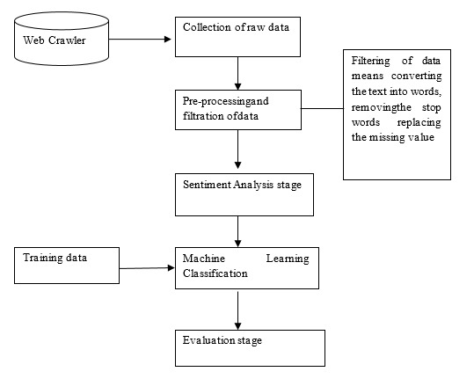
FIG 2: OVERALL ARCHITECTURE

6.3 UML Modelling:
Unified Modelling Language (UML) is a standardized notation utilized in software engineering for visualizing, specifying, constructing, and documenting software systems. It provides a comprehensive set of diagrams that represent various aspects of a system's structure, behaviour, and interactions. These diagrams include class diagrams for static structure depiction, sequence diagrams for dynamic interaction illustration, and many more.
UML modelling aids in communication among software developers, architects, and stakeholders, fostering a shared understanding of the system being developed. It serves as a blueprint for software design and implementation, guiding the development process from conceptualization to deployment. By using UML, teams can effectively capture requirements, identify potential design flaws, and refine system architecture.
Through UML, software projects benefit from improved clarity, reduced ambiguity, and enhanced maintainability. It enables teams to visualize complex systems, identify dependencies, and plan implementation strategies more effectively. Ultimately, UML modelling contributes to the development of high-quality software solutions by facilitating collaboration and aligning stakeholders' expectations with the implemented system.
6.3.1 Importance of UML in Modelling:
Unified Modeling Language (UML) plays a pivotal role in software engineering by providing a standardized framework for modeling software systems. Its importance lies in its ability to enhance communication, facilitate design, and improve the overall quality of software projects. UML diagrams serve as visual representations that help stakeholders, including developers, architects, and clients, to understand and analyze the system's architecture, structure, and behavior comprehensively. By using UML, teams can identify requirements, clarify design decisions, and detect potential issues early in the development process. This contributes to reducing development risks, improving collaboration among team members, and ensuring that the final software product meets stakeholders' expectations. Furthermore, UML's versatility allows it to adapt to various development methodologies, making it a valuable tool in agile, waterfall, and other software development approaches. Overall, UML significantly contributes to the success of software projects by providing a common language for effective communication and modeling.
6.4 Class Diagram:
A class diagram, a fundamental aspect of Unified Modeling Language (UML), serves as a blueprint for the static structure of software systems. In this diagram, classes are depicted as boxes, detailing their attributes and methods. Associations between classes are represented by lines, showing how classes interact and collaborate within the system.
Creating a class diagram for the sentiment analysis system involves identifying the main classes and their relationships within the system. Here's a simplified class diagram for the proposed sentiment analysis system:
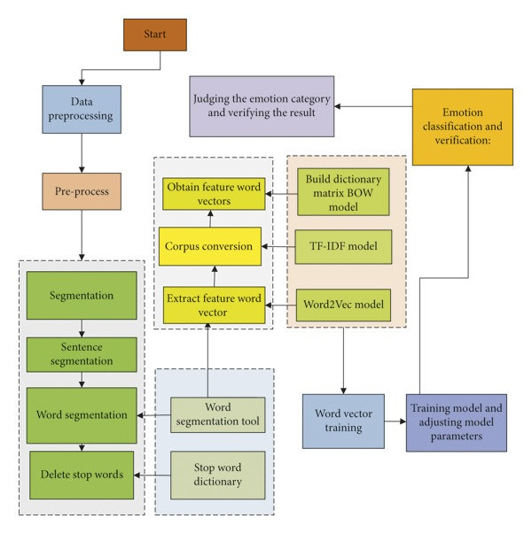
FIG 3: CLASS DIAGRAM
6.5 Use-Case Diagram:
A use case diagram in Unified Modeling Language (UML) offers a high-level overview of the interactions between users (actors) and a system. It illustrates the various use cases, representing specific functionalities or actions that users can perform within the system. Actors are depicted as stick figures, while use cases are represented as ovals. Lines connecting actors to use cases show the relationships and interactions between them. Here's a use case diagram for the sentiment analysis system:
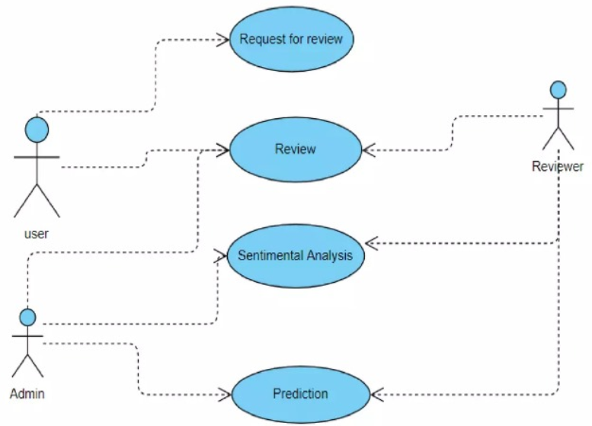
FIG 4: USE-CASE DIAGRAM
User: Represents the actor interacting with the system. In this case, the user could be an Amazon customer providing reviews.
Sentiment Analyzer: Represents the system being used by the user. It performs sentiment analysis on the reviews provided by the user.
Use Cases:
• Interacts with System: The user interacts with the sentiment analysis system.
• Provides Reviews: The user provides reviews (textual data) to the sentiment analysis system.
• Analyze Sentiment: The Admin analyzes the sentiment of the reviews provided by the user.
• Display Results: The Admin displays the sentiment analysis results to the user.
Association: The user interacts with the Admin to provide reviews and receive sentiment analysis results.

6.7 Sequence Diagram:
A sequence diagram in Unified Modeling Language (UML) illustrates the interactions between objects or components within a system over time, showcasing the flow of messages exchanged among them. Participants, representing objects or entities, are depicted as vertical lifelines. Messages, represented by arrows, indicate communication between participants, showcasing the chronological order of interactions. Activation bars denote the duration of an object's participation in a particular message exchange.
Sequence diagrams assist in requirements analysis, design validation, and system debugging, facilitating effective communication among stakeholders, including developers, designers, and clients. Overall, sequence diagrams serve as powerful tools for system modeling and analysis, contributing to the development of robust and efficient software solutions.
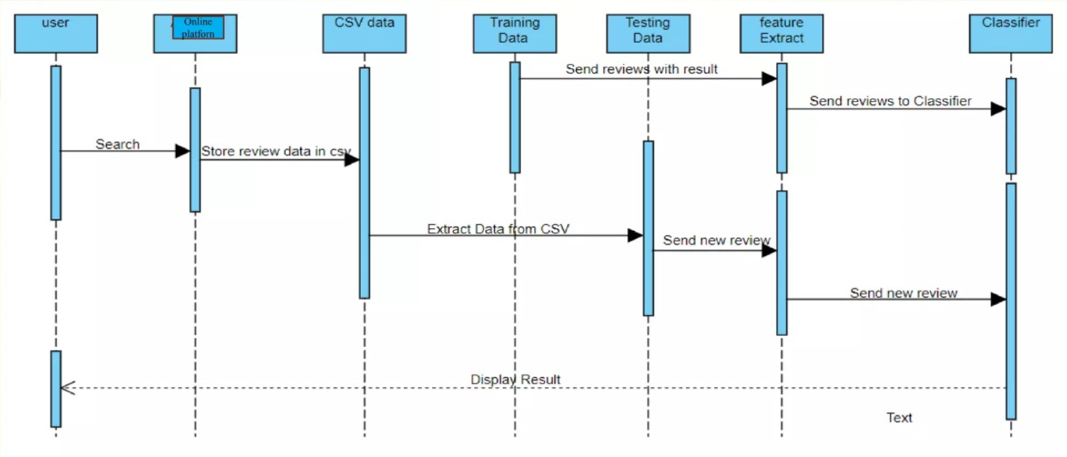
FIG 5: SEQUENCE DIAGRAM

CHAPTER-7
CODING

7. CODING

7.1 SOFTWARE DESCRIPTION:

7.1.1 CLASSIFICATION:
To classify reviews in different class (positive and negative) we build a classifier which consists of several machine learning classifiers. Classification is a supervised learning task where the goal is to predict the category or class label of a given input based on its features. In the context of sentiment analysis on Amazon food reviews, classification involves categorizing each review into one of several predefined sentiment classes, such as positive, negative, or neutral.
Classification is a process of categorizing a given set of data into classes, it can be performed on both structured or unstructured data. The classification predictive modeling is the task of approximating the mapping function from input variables to discrete output variables. The main goal is to identify which class/category the new data will fall into.
Logistic regression is specifically meant for classification, it is useful in understanding how a set of independent variables affect the outcome of the dependent variable.
The main disadvantage of the logistic regression algorithm is that it only works when the predicted variable is binary, it assumes that the data is free of missing values and assumes that the predictors are independent of each other.

7.1.2 LOGISTIC REGRESSION CLASSIFIER:
Logistic regression is one of the most popular Machine Learning algorithms, which comes under the Supervised Learning technique. It is used for predicting the categorical dependent variable using a given set of independent variables.
Logistic regression predicts the output of a categorical dependent variable. Therefore, the outcome must be a categorical or discrete value. It can be either Yes or No, 0 or 1, true or False, etc. but instead of giving the exact value as 0 and 1, it gives the probabilistic values which lie between 0 and 1.
Logistic Regression is much similar to the Linear Regression except that how they are used. Linear Regression is used for solving Regression problems, whereas Logistic regression is used for solving the classification problems.
In Logistic regression, instead of fitting a regression line, we fit an "S" shaped logistic function, which predicts two maximum values (0 or 1).
Logistic Regression is a significant machine learning algorithm because it has the ability to provide probabilities and classify new data using continuous and discrete datasets.
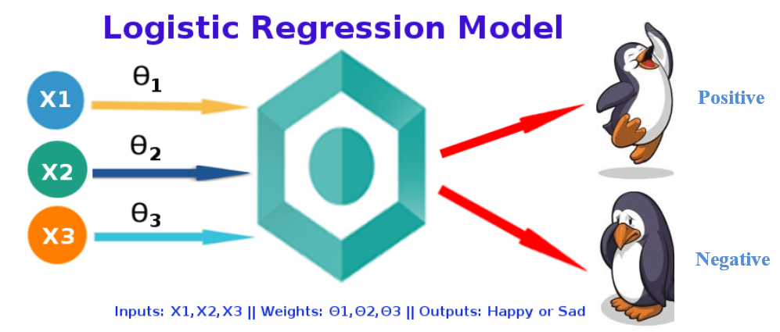
FIG6: LOGISTIC REGRESSION

7.1.2 INTRODUCTION TO SVM:
Support Vector Machine or SVM is one of the most popular Supervised Learning algorithms, which is used for Classification as well as Regression problems. However, primarily, it is used for Classification problems in Machine Learning.
The goal of the SVM algorithm is to create the best line or decision boundary that can segregate n-dimensional space into classes so that we can easily put the new data point in the correct category in the future. This best decision boundary is called a hyper plane.
Linear SVM: Linear SVM is used for linearly separable data, which means if a dataset can be classified into two classes by using a single straight line, then such data is termed as linearly separable data, and classifier is used called as Linear SVM classifier.
Non-linear SVM: Non-Linear SVM is used for non-linearly separated data, which means if a dataset cannot be classified by using a straight line, then such data is termed as non-linear data and classifier used is called as Non-linear SVM classifier.
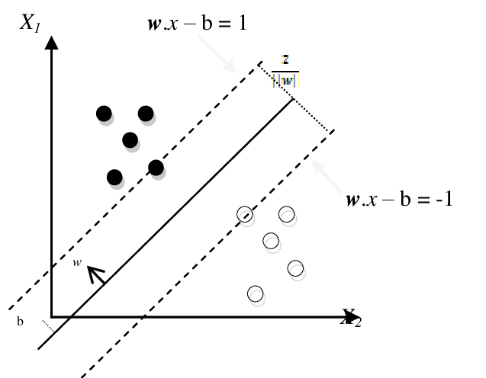
FIG 7: SVM
7.1.3 RANDOM FOREST:
Random forests are a supervised Machine learning algorithm that is widely used in regression and classification problems and produces, even without hyperparameter tuning a great result most of the time. It is perhaps the most used algorithm because of its simplicity. It builds a number of decision trees on different samples and then takes the majority vote if it’s a classification problem
Random Forest offers several advantages for sentiment analysis tasks, each decision tree predicts the sentiment (positive, neutral, or negative) of a given review based on its TF-IDF representation. It tends to provide high accuracy, robustness to overfitting, and the ability to handle high-dimensional data with large feature spaces, such as TF-IDF representations of text data. By aggregating the predictions of multiple decision trees, Random Forest can effectively capture complex relationships and patterns in the data, leading to reliable sentiment classification results
FIG 8: RANDOM FOREST
7.2 CODING
import nltk
nltk.download('stopwords')
from nltk.corpus import stopwords
import numpy as np
import pandas as pd
reviews_data = pd.read_csv('food_reviews_csv_excel.csv')
reviews_data.head()
reviews_data.shape
# Checking the available features of the dataset
reviews_data.columns
reviews_data.dtypes
# Checking for null values
reviews_data.isnull().sum()
# Checking out random sample review
reviews_data['Text'][10]
reviews_data['Summary'][10]
# Data Pre-processing
### Removing any row with null values from the dataset
reviews_data.dropna(inplace=True)
reviews_data.isnull().sum()
### Removing any unwanted feature columns from the dataset
reviews_data.drop(['ProfileName','Id'],axis=1,inplace=True)
reviews_data.head()
reviews_data.Summary = reviews_data.Summary.apply(str)
reviews_data['Text']=reviews_data['Text'].astype(str)
reviews_data['Summary_Text']=reviews_data[['Summary','Text']].agg(' '.join,axis=1)
reviews_data.head()
### Droppping the Summary and Text Columns
reviews_data.drop(['Summary','Text'],axis=1,inplace=True)
reviews_data.head()
# Pre-processing of the Time Column
reviews_data['Time_ymd']=reviews_data['Time'].apply(lambda col: datetime.utcfromtimestamp(int(col)).strftime('%Y-%m-%d'))
# converting unix time to year/month format
reviews_data['Time_ym']=reviews_data['Time'].apply(lambda col: datetime.utcfromtimestamp(int(col)).strftime('%Y-%m'))
# Drop Time column
reviews_data.drop(['Time'] ,axis=1, inplace=True)
reviews_data.head()
# Helpness Ratio
reviews_data['Helpness_Score']=np.where(reviews_data['HelpfulnessDenominator']>0,reviews_data['HelpfulnessNumerator']/reviews_data['HelpfulnessDenominator'],-1)
reviews_data.head()
### Dropping the HelpfulnessNumerator and HelpfulnessDenominator Columns
reviews_data.drop(['HelpfulnessDenominator','HelpfulnessNumerator'],axis=1,inplace=True)
reviews_data.head()
# Handling any duplicate data
reviews_data[reviews_data.duplicated(['UserId','ProductId'])].count()
# Droppping duplicate records and keeping the latest one per group
reviews_data=reviews_data.drop_duplicates(subset=['UserId','ProductId'], keep='last', inplace=False)
# Check if the duplicates are still there
reviews_data[reviews_data.duplicated(['UserId','ProductId'])].count()
reviews_data.shape
# Text Cleaning of the Summary_Text Column
import re
import string
punctuation = set(string.punctuation)
stop_words = set(stopwords.words("english"))
stop_words.update(["br", "href","good","great","amazon","product", "counter"])
## Defining a custom function to clean the input text of the useless punctuations and stopwords
def Clean_Text(review):
x = review
x = re.sub(r'https?:\S*', '', x)
x = re.sub(r'{link}', '', x) #remove links
x = re.sub(r'@[\w]*', '', x)
x = re.sub(r'[^A-Za-z0-9]+', ' ', x)
x = re.sub(r'\b[0-9]+\b', '', x)
x = re.sub(r'&[a-z]+', '', x)
x = ''.join(w for w in x if w not in punctuation)
x = x.replace('[^a-zA-Z#]',' ') # Remove special
x = [w.lower() for w in x.split() if w.lower() not in stop_words]
x = [w for w in x if len(w) > 3]
return x
# Applying the Clean_Text function on all the Summary_text
reviews_data['Clean_Text']=reviews_data['Summary_Text'].apply(lambda x:Clean_Text(x))
reviews_data.head()
## Checking the size of reviews
reviews_data['Review_length']=reviews_data['Clean_Text'].apply(lambda x:len(x))
reviews_data['Review_length'].describe()
# Plotting the review length
import matplotlib.pyplot as plt
reviews_data['Review_length'].hist(bins=1000)
plt.xlim(0,350)
plt.title('Review Lenght Distribution')
# Checking the Review Scores
import seaborn as sns
sns.countplot(x='Score',data=reviews_data)
plt.xlabel('Review Scores')
plt.ylabel('Review Count')
plt.title('Review Score Count')
# Sentiment Analysis
# Reviews with score > 3 are considered as positive
# Reviews with score <3 are considered as negative
# Reviews with score =3 are considered as neutral
def score_classification(score):
if score > 3:
return 1
elif score == 3:
return 2
else:
return 0
## Positive = 1, Neutral = 2, Negative = 0
reviews_data['Sentiment']=reviews_data['Score'].apply(lambda x:score_classification(x))
reviews_data.head()
reviews_data['Sentiment'].value_counts()
sns.countplot(x='Sentiment',data=reviews_data)
plt.title('Review Count for each sentiment')
# Sentiment Analysis
# Creating Word Collector for positive, negative and neutral reviews
from collections import Counter
positive_reviews=Counter()
negative_reviews=Counter()
neutral_reviews=Counter()
total_reviews=Counter()
# Get individual review, score (0/1/2) and actual score 1-5 from dataframe in the vector form
reviews_vector=reviews_data['Clean_Text']
score_vector=reviews_data['Sentiment']
actual_score_vec=reviews_data['Score']
# Sample Negative Review
for i,review in enumerate(reviews_vector):
if(i>10 and i<16 and score_vector[i]==0 and actual_score_vec[i]!=3):
print('Negative, Actual score =', actual_score_vec[i],', Review index = ',i,'\n')
print(review)
print(' \n')
# Sample Positive Review
for i,review in enumerate(reviews_vector):
if(i>10 and i<16 and score_vector[i]==1 and actual_score_vec[i]!=3):
print('Positive, Actual score =', actual_score_vec[i],', Review index = ',i,'\n')
print(review)
# Positive/negative/neutral and total reviews per each review one by one
for review, score in zip(reviews_vector, score_vector):
for word in review:
total_reviews[word] = total_reviews.get(word,0) + 1
if score == 0:
negative_reviews[word] = negative_reviews.get(word, 0) + 1
elif score == 1:
positive_reviews[word] = positive_reviews.get(word, 0) + 1
elif score == 2:
neutral_reviews[word] = neutral_reviews.get(word , 0) + 1
from nltk import FreqDist
# Most Common Words in Negative Reviews
negative_FreqDist= FreqDist(negative_reviews)
negative_FreqDist.most_common(10)
# Frequency Distribution Plot for Negative Reviews
negative_FreqDist.plot(10,cumulative=True)
from wordcloud import WordCloud
def generate_word_cloud(Text):
wordcloud = WordCloud(
background_color='white',
width = 1000,
height = 500).generate(str(Text))
fig = plt.figure(
figsize = (10, 6),
facecolor = 'k',
edgecolor = 'k')
plt.imshow(wordcloud, interpolation = 'bilinear')
plt.axis('off')
plt.tight_layout(pad=0)
plt.show()
# Positive Reviews Frequency Distribution
positive_FreqDist = FreqDist(positive_reviews)
positive_FreqDist.most_common(20)
positive_FreqDist.plot(20,cumulative=True)
# Collecting High Polar Word
# Words that are highly positive / negative
counter_pos_negative = Counter()
for word, frequency in total_reviews.most_common():
if frequency > 100:
try:
counter_pos_negative[word]=np.log(positive_FreqDist[word]/float(negative_FreqDist[word]+1))
except:
continue
# Top most polar words
top_positive=dict(counter_pos_negative.most_common(40))
top_negative=dict(counter_pos_negative.most_common()[:-40:-1])
# Word Cloud - Positive Sentiments
generate_word_cloud(top_positive)
# Top Words in Positive Reviews
plt.figure(figsize=(20,6))
sns.barplot(x=list(top_positive.keys()),y=list(top_positive.values()), palette="Blues_d")
plt.xticks(rotation=45,fontsize=14);
plt.title('Top words in positive reviews',fontsize=20);
plt.tight_layout();
# Word Cloud - Negative Sentiments
generate_word_cloud(top_negative)
# Top Words in Negative Reviews
plt.figure(figsize=(20,6))
sns.barplot(x=list(top_negative.keys()), y=list(top_negative.values()), palette="Oranges_d")
plt.xticks(rotation=90,fontsize=14);
plt.title('Top words in negative reviews',fontsize=20);
plt.tight_layout();
# Model Building
from sklearn.model_selection import train_test_split
from sklearn.feature_extraction.text import TfidfVectorizer
from sklearn.linear_model import LogisticRegression
from sklearn.metrics import accuracy_score
# Split the data into features and target
X = reviews_data['Clean_Text']
y = reviews_data['Score']
X.head()
y.head()
# Split the dataset into training and testing sets
X_train, X_test, y_train, y_test = train_test_split(X, y, test_size=0.2, random_state=42)
X_train_list = X_train.tolist()
X_test_list = X_test.tolist()
print(type(X_train_list))
# Convert text data into numerical representations using TF-IDF
tfidf_vectorizer = TfidfVectorizer(max_features=5000)
X_train_tfidf = tfidf_vectorizer.fit_transform([' '.join(x) for x in X_train_list])
X_test_tfidf = tfidf_vectorizer.transform([' '.join(x) for x in X_test_list])
# Build and train the sentiment analysis model (Logistic Regression)
model = LogisticRegression()
model.fit(X_train_tfidf, y_train)
# Predict sentiment on the testing set
y_pred = model.predict(X_test_tfidf)
# Calculate accuracy
accuracy = accuracy_score(y_test, y_pred)
print("Accuracy of the sentiment analysis model:", accuracy)
# Importing necessary libraries
from sklearn.svm import SVC
# Build and train the sentiment analysis model (Support Vector Machine)
svm_model = SVC(kernel='linear')
svm_model.fit(X_train_tfidf, y_train)
# Predict sentiment on the testing set using SVM
y_pred_svm = svm_model.predict(X_test_tfidf)
# Calculate accuracy using SVM
accuracy_svm = accuracy_score(y_test, y_pred_svm)
print("Accuracy of the sentiment analysis model using SVM:", accuracy_svm)
# Importing necessary libraries
from sklearn.ensemble import RandomForestClassifier
# Build and train the sentiment analysis model (Random Forest)
rf_model = RandomForestClassifier(n_estimators=100, random_state=42)
rf_model.fit(X_train_tfidf, y_train)
# Predict sentiment on the testing set using Random Forest
y_pred_rf = rf_model.predict(X_test_tfidf)
# Calculate accuracy using Random Forest
accuracy_rf = accuracy_score(y_test, y_pred_rf)
print("Accuracy of the sentiment analysis model using Random Forest:", accuracy_rf)

CHAPTER-8
RESULTS

8. RESULTS

This chapter presents the results and findings obtained from the implementation and evaluation of the proposed system, including performance metrics, accuracy, and effectiveness in sentiment analysis of Amazon food reviews.

Accuracy:
Accuracy measures the proportion of correctly classified instances among the total number of instances. It is a fundamental metric in classification tasks, indicating how well a model performs overall. High accuracy signifies that the model is making correct predictions across different classes, while low accuracy suggests misclassification errors. However, accuracy alone may not provide a complete picture, especially in imbalanced datasets, where it can be misleading.
Logistic Regression model result:
Fig 9.1: Accuracy of Logistic Regression Model
SVM model result:
Fig 9.2: Accuracy of SVM Model
Random Forest result:
Fig 9.3: Accuracy of Random Forest Model

Size Of Dataset:

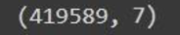

Fig 10.1: Before Cleaning Fig 10.2: After Cleaning

Distribution graph:

Fig 11: Review Length Distribution

Counter Plot:

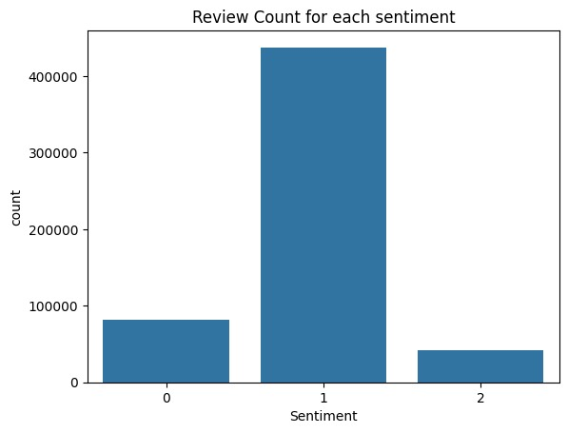
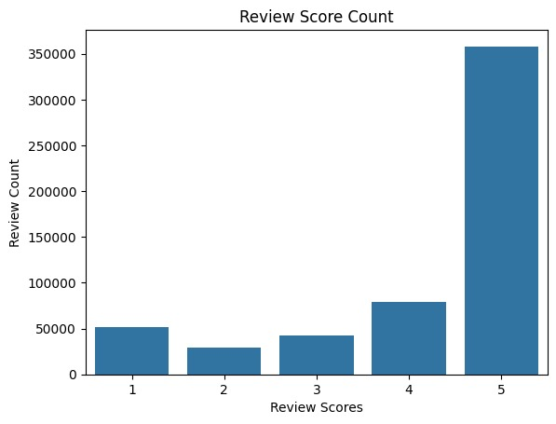
Fig 11.1: Review Score Count Fig 11.2: Review Count for each Sentiment

Curve Graph:

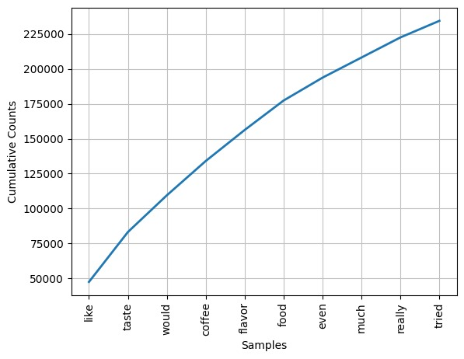
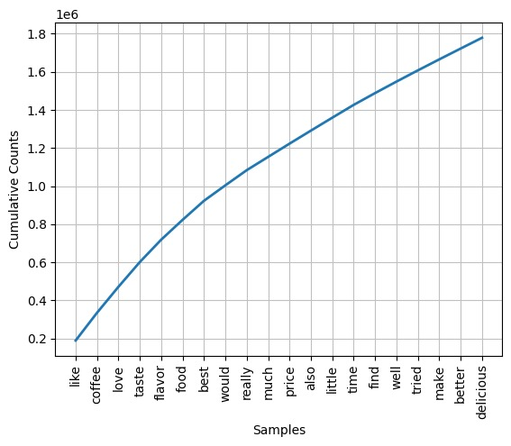
Fig 12.1: Frequency Distribution Plot for Positive Reviews Fig 12.2: Frequency Distribution Plot for Negative Reviews
Word cloud results:
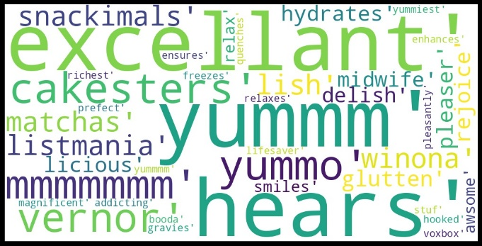
Fig 13.1: Word Cloud of high polar positive words
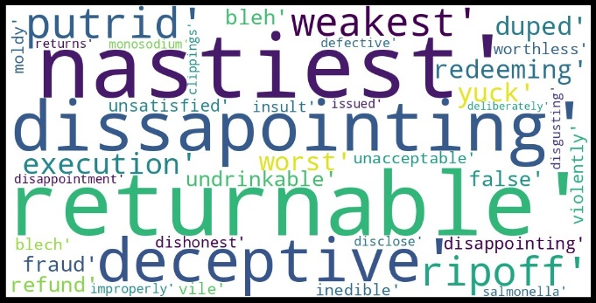
Fig 13.2: Word Cloud of high polar negative words

Polar Words Frequency:

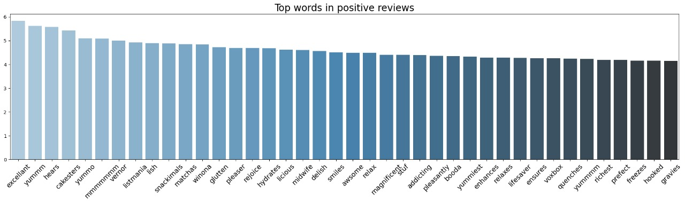
Fig 14.1: High polar positive words

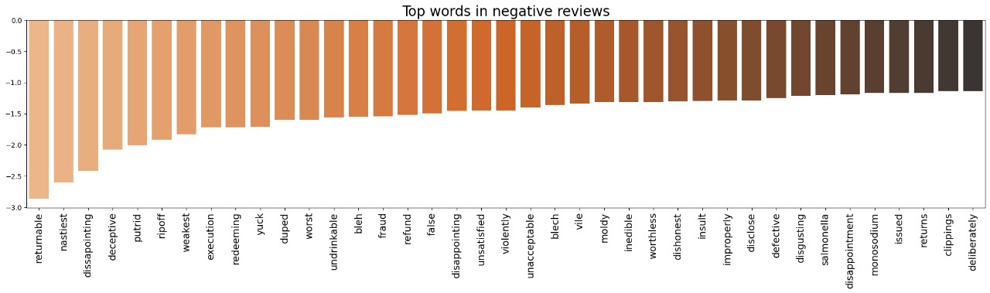
Fig 14.2: High polar negative words

CHAPTER-9
APPLICATIONS AND USE CASE

9. APPLICATIONS AND USE CASE
9.1 APPLICATIONS:
Certainly, here are four applications of sentiment analysis across different fields:
1. Healthcare: Patient Experience Monitoring:
Sentiment analysis can be applied to patient feedback collected through surveys, online reviews, and social media to monitor the patient experience in healthcare settings. By analyzing sentiments expressed in patient feedback, healthcare providers can identify areas for improvement, address patient concerns, and enhance overall patient satisfaction. This application helps healthcare organizations prioritize patient-centered care initiatives and optimize healthcare service delivery.
2. Finance: Market Sentiment Analysis:
In the finance industry, sentiment analysis can be used to analyze market sentiment and investor emotions expressed in news articles, social media discussions, and financial reports. By monitoring sentiment trends, financial analysts and investors can gain insights into market sentiment shifts, investor sentiment towards specific assets or industries, and potential market volatility. This application helps investors make informed investment decisions, anticipate market movements, and manage investment risks effectively.
3. Education: Student Feedback Analysis:
Sentiment analysis can be employed to analyze student feedback collected through course evaluations, online forums, and student surveys in educational institutions. By analyzing sentiment expressed in student feedback, educators and administrators can gain insights into student satisfaction levels, identify areas for curriculum improvement, and address student concerns or challenges. This application enables educational institutions to enhance teaching quality, tailor educational programs to student needs, and improve overall student satisfaction and retention.
4. Tourism: Destination Sentiment Analysis:
In the tourism industry, sentiment analysis can be utilized to analyze sentiments expressed in traveler reviews, social media posts, and online forums about tourist destinations. By analyzing destination sentiment, tourism boards, travel agencies, and hospitality businesses can gain insights into traveler preferences, identify popular attractions, and assess destination reputation. This application helps tourism stakeholders develop targeted marketing campaigns, improve destination management strategies, and enhance the overall tourist experience.
9.2 USES CAES:
Here are some common use cases for sentiment analysis:
Brand Monitoring: Companies use sentiment analysis to monitor social media, review sites, and other online platforms to gauge public perception of their brand. By analyzing sentiments expressed in customer feedback, companies can identify areas for improvement, track brand reputation, and address potential issues before they escalate.
Customer Feedback Analysis: Sentiment analysis helps businesses analyze customer feedback from surveys, reviews, and support tickets. By categorizing sentiments as positive, negative, or neutral, companies can quickly identify trends, prioritize customer concerns, and make data-driven decisions to enhance customer satisfaction.
Market Research: In market research, sentiment analysis is used to analyze consumer opinions and preferences regarding products, services, and brands. By analyzing sentiments expressed in forums, social media discussions, and product reviews, businesses can gain insights into consumer sentiment, identify emerging trends, and make informed marketing strategies.
Product Feedback and Reviews: E-commerce platforms and product manufacturers use sentiment analysis to analyze product reviews and ratings. By understanding customer sentiments, businesses can identify product strengths and weaknesses, prioritize product improvements, and optimize marketing strategies to increase sales and customer satisfaction.

CHAPTER-10
CONCLUSION

10. CONCLUSION

The sentiment analysis project on Amazon food reviews offers valuable insights into customer sentiments and perceptions regarding various food products available on the platform. Through the utilization of natural language processing techniques and machine learning algorithms, this project successfully categorizes reviews into positive, negative, and neutral sentiments based on the expressed opinions.

By analyzing nearly 5 lakh records of Amazon food reviews, the project demonstrates the significance of sentiment analysis in understanding consumer behavior and preferences. Through data preprocessing, including cleaning, feature engineering, and handling duplicates, the dataset was prepared for analysis. The incorporation of text cleaning techniques, such as removing punctuation marks, special characters, and stop words, ensured the accuracy and relevance of the sentiment analysis results.

The sentiment analysis model, built using logistic regression, support vector machines (SVM), and random forest algorithms, achieved high accuracy in predicting sentiment labels for the reviews. The evaluation of the models demonstrated their effectiveness in categorizing reviews into positive, negative, and neutral sentiments, providing actionable insights for businesses and stakeholders.

Moreover, visualizations such as word clouds and frequency distributions highlighted the most common words associated with positive and negative sentiments, offering a deeper understanding of the factors influencing customer perceptions. Overall, this project underscores the importance of sentiment analysis in extracting valuable insights from vast amounts of customer-generated data and its potential to inform decision-making processes in the food industry.

Looking ahead, there is considerable scope for advancing and refining the sentiment analysis project. Future enhancements could include exploring advanced text processing techniques such as word embeddings and deep learning architectures for improved sentiment analysis performance. Additionally, fine-grained sentiment analysis, aspect-based sentiment analysis, and integration of multimodal data sources could offer more nuanced insights and cater to diverse application scenarios.

Furthermore, the project could be extended to real-time sentiment analysis and adaptation to different domains, enabling businesses to monitor sentiment trends and make informed decisions in a timely manner. Continuous evaluation and refinement of sentiment analysis models would be essential to ensure robust performance and applicability across various contexts and industries.

CHAPTER-11
FUTURE ENHANCEMENT

11. FUTURE ENHANCEMENT

In considering the future empowerment of our sentiment analysis project, several key strategies can be explored to enhance its capabilities and relevance in evolving business landscapes. These strategies aim to leverage emerging technologies and methodologies to improve the accuracy, interpretability, and adaptability of sentiment analysis solutions. By incorporating these advancements, the project can provide more valuable insights and support informed decision-making processes for businesses across various industries
1. Enhanced Text Processing Techniques:
Expanding the sentiment analysis project involves exploring advanced text processing techniques beyond TF-IDF. Methods like word embeddings (e.g., Word2Vec, GloVe) capture intricate semantic relationships within textual data. Additionally, leveraging deep learning architectures such as recurrent neural networks (RNNs) or transformer models could yield more nuanced sentiment analysis results. These techniques have the potential to capture context and nuances in language more effectively, thereby enhancing the accuracy and granularity of sentiment classification.
2. Specialized Sentiment Analysis Applications:
Future iterations of the project could focus on specialized sentiment analysis applications, such as fine-grained sentiment analysis and aspect-based sentiment analysis. Fine-grained sentiment analysis involves categorizing sentiments into more detailed levels (e.g., very positive, slightly positive, neutral, slightly negative, very negative), providing more nuanced insights into sentiment variations. Aspect-based sentiment analysis, on the other hand, delves into analyzing sentiment towards specific aspects or features mentioned in reviews, offering targeted feedback for product improvement or service enhancement.
3.Real-Time and Domain-Specific Solutions:
Another avenue for future development lies in real-time sentiment analysis capabilities and domain-specific adaptations. Implementing real-time sentiment analysis allows businesses to
monitor sentiment trends in streaming data from social media, review platforms, or customer feedback channels promptly. Moreover, tailoring sentiment analysis models to different domains or industries (e.g., healthcare, finance, hospitality) ensures that the analysis is optimized for specific business needs and challenges within those domains. By incorporating domain-specific lexicons, knowledge bases, and contextual understanding, these models can provide more accurate and actionable insights for decision-making and customer engagement strategies.

CHAPTER-12
REFERENCES

12. REFERENCES

12.1 REFERENCES:
- T. U. Hague, N. N. Saber and F. M. Shah, "Sentiment analysis on large scale Amazon product reviews", 2018 IEEE International Conference on Innovative Research and Development (ICIRD), 2018.
- Almjawel, S. Bayoumi, D. Alshehri, S. Alzahrani and M. Alotaibi, "Sentiment Analysis and Visualization of Amazon Books’ Reviews", 2019 2nd International Conference on Computer Applications & Information Security (ICCAIS), 2019.
- CVM Krishna, GA Rao, S AnuRadha, KVD Sagar, “Prediction of User Overall Gratification in Indian Tourism Domain on Hotel Classes and Trip Types”, ECS Transactions 107 (1), 19813
- L. B. Shyamasundar and P. J. Rani, "Twitter sentiment analysis with different feature extractors and dimensionality reduction using supervised learning algorithms", 2016 IEEE Annual India Conference (INDICON), 2016.
- K. Shalini, H. B. Ganesh, M. A. Kumar and K. P. Soman, "Sentiment Analysis for Code-Mixed Indian Social Media Text With Distributed Representation", 2018 International Conference on Advances in Computing. Communications and Informatics (ICACCI), pp. 1126-1131, 2018.
- CVM Krishna, KB Sri, S Avinash, DA Priya, G Yamini, “Users preference assessment on overall gratification in asiantourism hotels before and after pandemic”, AIP Conference Proceedings 2796 (1)
- Saisrihitha Yadlapalli, R. Reddy and T. Sasikala, Advanced Twitter Sentiment Analysis Using Supervised Techniques and Minimalistic Features, 2020.
- CVM Krishna, AC Sri, S Ayesha, GR Lakshmi, DP Shankar, “Impact of user reviews and ratings on overall rating in Indian tourism hotels”, AIP Conference Proceedings 2796 (1).
- T. U. Hague, N. N. Saber and F. M. Shah, "Sentiment analysis on large scale Amazon product reviews", 2018 IEEE International Conference on Innovative Research and Development (ICIRD), 2018.
- A. Almjawel, S. Bayoumi, D. Alshehri, S. Alzahrani and M. Alotaibi, "Sentiment Analysis and Visualization of Amazon Books’ Reviews", 2019 2nd International Conference on Computer Applications & Information Security (ICCAIS), 2019.
- L. B. Shyamasundar and P. J. Rani, "Twitter sentiment analysis with different feature extractors and dimensionality reduction using supervised learning algorithms", 2016 IEEE Annual India Conference (INDICON), 2016.
- K. Shalini, H. B. Ganesh, M. A. Kumar and K. P. Soman, "Sentiment Analysis for Code-Mixed Indian Social Media Text With Distributed Representation", 2018 International Conference on Advances in Computing. Communications and Informatics (ICACCI), pp. 1126-1131, 2018.
- CVM Krishna, GA Rao, S Anuradha, “Analysing the impact of contextual segments on the overall rating in multi-criteria recommender systems”, Journal of big Data 10 (1), 16
- Saisrihitha Yadlapalli, R. Reddy and T. Sasikala, Advanced Twitter Sentiment Analysis Using Supervised Techniques and Minimalistic Features, 2020.

CHAPTER-13
CERTIFICATES

13. CERTIFICATES



CHAPTER-13
PUBLISHED PAPER

